MMV LAI Parameter Explorer - User Guide
Venelin Mitov, Ghaith Aljayyoussi, Peter Webborn, Mark Gardner, Sam Jones, Nathalie Gobeau, Jeremy Burrows, Steven Brand
Version 1.4.1, November 2026
© 2026 Medicines for Malaria Venture. All rights reserved.
Suggested citation: Venelin Mitov, Ghaith Aljayyoussi, Peter Webborn, Mark Gardner, Sam Jones, Nathalie Gobeau, Jeremy Burrows, Steven Brand (2026). MMV LAI Parameter Explorer - User Guide, version 1.4.1. Medicines for Malaria Venture. https://laiparameter.mmv.org

Introduction
The LAI Parameter Explorer helps you answer two questions about a Long-Acting Injectable (LAI) antimalarial drug candidate, given its unbound pharmacokinetic (PK) and pharmacodynamic (PD) parameters:
- What is the largest in-vivo MIC,u that the recommended MMV Critical Late-Lead dose of 400 mg would still cover for a chosen coverage duration?
- What is the minimum dose needed to keep the unbound plasma concentration above the compound’s in-vivo MIC,u for that duration?
Chapter 1 walks through a complete worked example, from obtaining predicted unbound parameters in MMVFree to reading the answers off both plot types in the Prediction tab.
Chapter 2 is a comprehensive reference covering every input, output, and interactive feature of the app.

1 Getting Started
This chapter walks through a complete example using a hypothetical compound. You will: obtain predicted unbound PK and PD parameters from MMVFree, enter them into the LAI Parameter Explorer, explore the Max MIC,u plot to answer question 1, and then switch to the Min Dose plot to answer question 2.
A tip before you start: screenshots appear blurred when the browser downscales them. Right-click any screenshot and choose Open image in new tab (or equivalent in your browser) to view it at full resolution.

Step 1: Obtain unbound parameters from MMVFree
Open MMVFree and go to the Input Data tab. Enter the following example values for your compound in the table row (click any cell in the row to edit it):
Parameter | Value
Molecular Weight (Da) | 420
Human Blood to Plasma Ratio | 1
Human Plasma Protein Binding (%) | 90
Human Microsome Binding (%) | 70
Human Mic. CLint (µL/min/mg protein) | 0.9
Rat Plasma Vss (L/kg) | 4
TCGLS 3D7 72h IC50 (nM) | 2
in vitro Hill Slope (power) | 6
Log10 in vitro PRR / 48h (log10 ratio) | 3
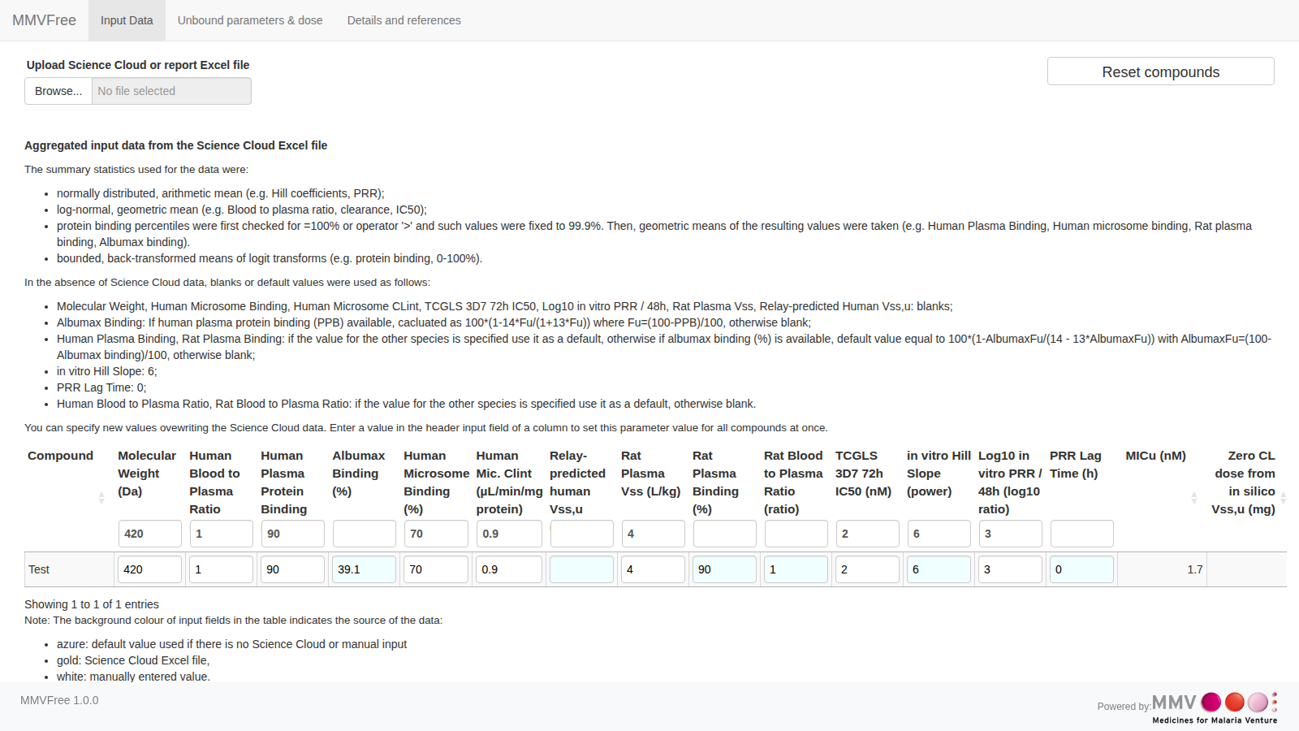
Once entered, open the Unbound parameters & dose tab. The table at the top lists the predicted unbound parameters for your compound. Read off the three values you will transfer to the LAI Parameter Explorer:
- Human CL,u (mL/min/kg) = 2.445
- Vss,u (L/kg) = 40 (from the in vivo row)
- TCGLS 3D7 IC50,u (nM) = 1.217
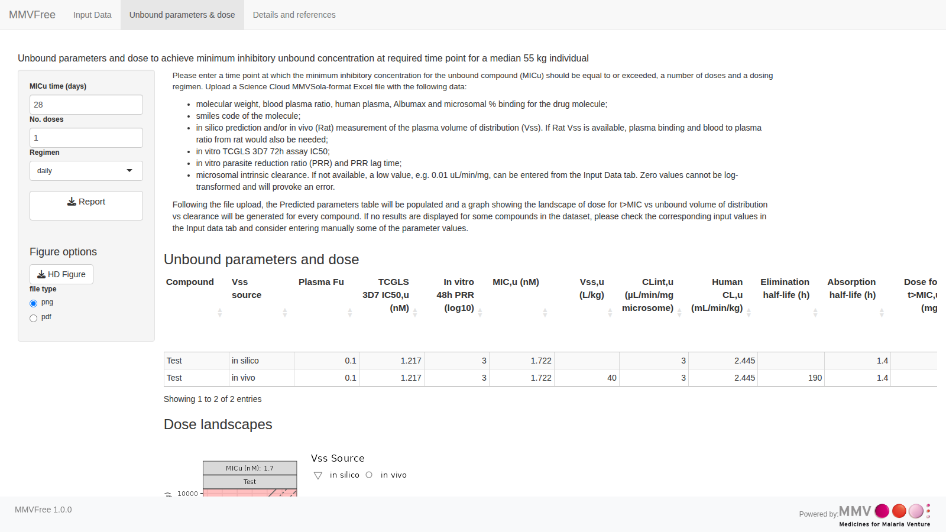

Step 2: Enter the parameters into the LAI Parameter Explorer
Open the LAI Parameter Explorer and go to the Prediction tab. In the left panel, enter the values transferred from MMVFree together with the PD parameters that are shared between the two tools:
Parameter | Value | Source
LAI Bioavailability | 1 | Assumed (same as in MMVFree)
CL,u (mL/min/kg) | 2.445 | MMVFree prediction
Vss,u (L/kg) | 40 | MMVFree prediction (in vivo)
TCGLS 3D7 72h IC50,u (nM) | 1.217 | MMVFree prediction
Hill Slope | 6 | Same as entered in MMVFree
Log10 in vitro PRR / 48h | 3 | Same as entered in MMVFree
The simulation runs automatically. The Your Drug panel on the right confirms the entered values and shows the derived elimination half-life (≈ 7.87 days) and the minimum doses for your specific CL,u / Vss,u combination.

Tip: skip manual entry with a pre-filled link
Instead of typing each value from the table above, you can open the LAI Parameter Explorer with them already filled in by appending a query string to the app’s URL. Each parameter is passed as name=value, joined with &. For example, appending the following to the app’s URL pre-fills exactly the values from the table above:
?LAI_Bioavailability=1&Clu_mLminkg=2.445&Vssu_Lkg=40&IC50=1.217&HillIN=6&invitroPRR=3
so the full link looks like <app URL>/?LAI_Bioavailability=1&Clu_mLminkg=2.445&Vssu_Lkg=40&IC50=1.217&HillIN=6&invitroPRR=3 (substitute the address you use to reach the app for <app URL>). Try it: it should land you directly on the screen shown at the end of Step 2, ready to jump to Step 3.
Only the parameters in the table above (plus Mwt, kaMax, and LagTime) can be set this way; any value that is missing or cannot be parsed is left at its default. See the Reference Guide for the full list of accepted parameter names and units.

Step 3: Explore the Max MIC,u plot: answering question 1
By default, the Type of Main Plot dropdown is set to Max MIC,u. The plot answers the first question: what is the largest in-vivo MIC,u that the standard 400 mg dose would still cover for 3 months?
Each cell shows the maximum in-vivo MIC,u (nM) that the 400 mg dose would maintain above the MIC threshold for the selected coverage duration. Cells with larger max MIC,u values are more favourable in the sense that even if the drug is not highly potent (does not have a small MIC,u), a 400 mg dose would still maintain concentrations high enough to prevent infection for the selected duration. The grey dot marks the Your Drug position on the grid.
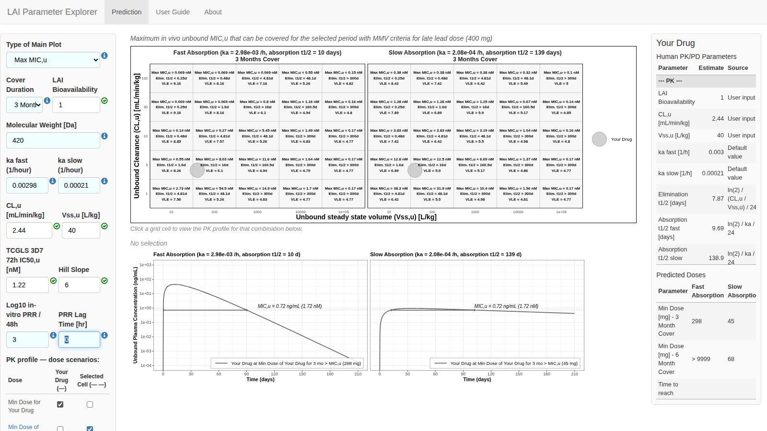
Click a cell adjacent to the Your Drug dot to compare how nearby PK combinations perform. The selected cell is highlighted, its coordinates appear below the plot, and the PK profile panel updates to overlay the concentration-time curve for the selected cell alongside Your Drug’s curve. This lets you see the PK shape that underlies the Max MIC,u answer.
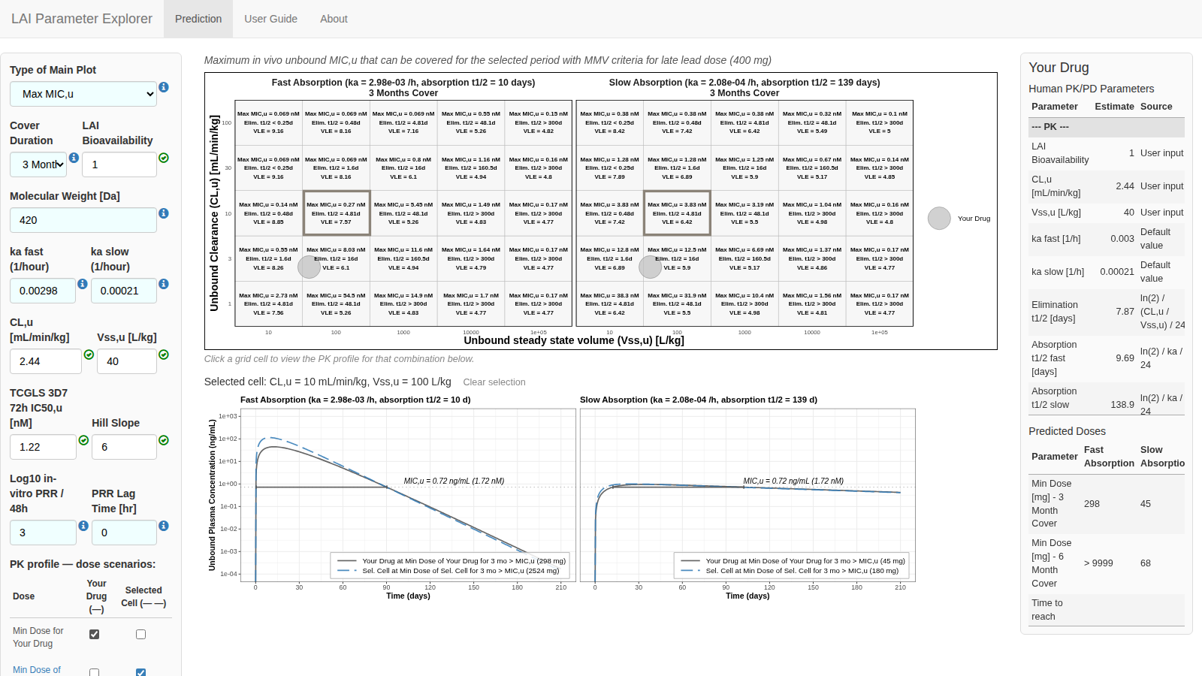

Step 4: Switch to the Min Dose plot: answering question 2
Change the Type of Main Plot dropdown to Min Dose. The grid cells now show a heatmap of the minimum dose (mg) required to keep the unbound plasma concentration above the in-vivo MIC,u for the selected coverage duration - answering the second question.
Cells are colour-coded: green (≤ 400 mg, meets the MMV criteria for late lead), orange (401-999 mg), and red (≥ 1000 mg). The Your Drug dot and the selected cell carry over from the previous view, so you can read off the minimum dose for the same cell you just explored on the Max MIC,u plot.
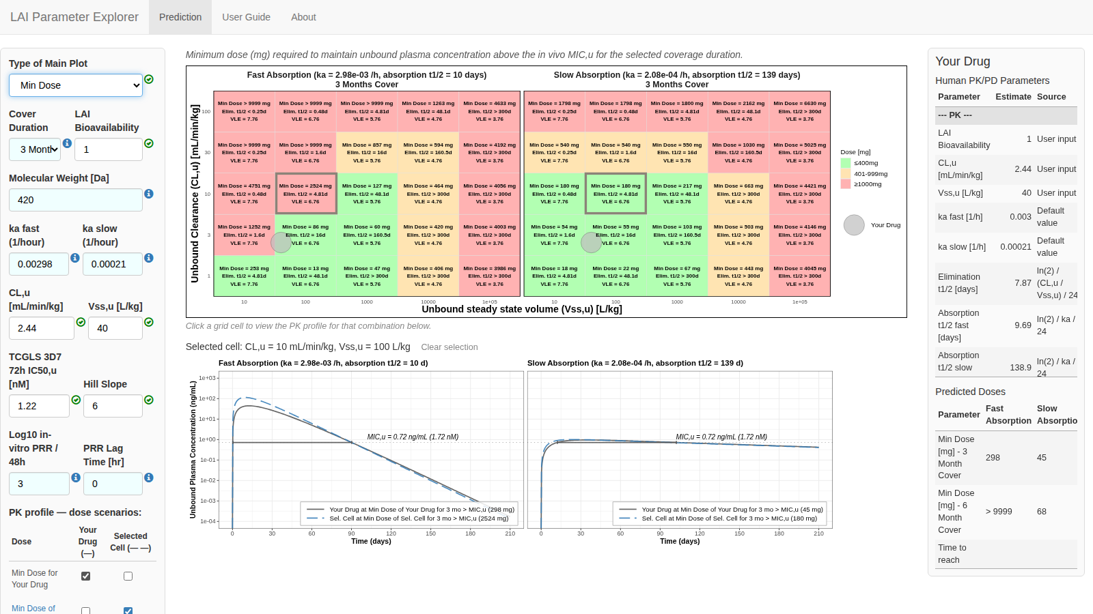

Step 5: Explore PK profiles
The PK profile panel below the main plot lets you visualise the simulated concentration-time curves that underlie the dose and MIC,u predictions. Use the PK profile: dose scenarios tickbox table in the lower left panel to overlay different combinations.
An important point to keep in mind: the only PK difference between Your Drug and the Selected Cell is their CL,u and Vss,u values. All PD parameters - IC50,u, Hill Slope, Log10 PRR - are the same for both. The selected cell simply represents a different point on the PK grid.
By default, two curves are shown for each absorption scenario: Your Drug at its own minimum dose (dark grey, solid) and the Selected Cell at its own minimum dose (blue, long-dashed). To add a third curve, tick MMV Criteria for Late Lead / Your Drug: this overlays Your Drug’s concentration-time profile at the fixed 400 mg dose (red, solid), letting you see whether 400 mg keeps Your Drug above the MIC for the full coverage period.
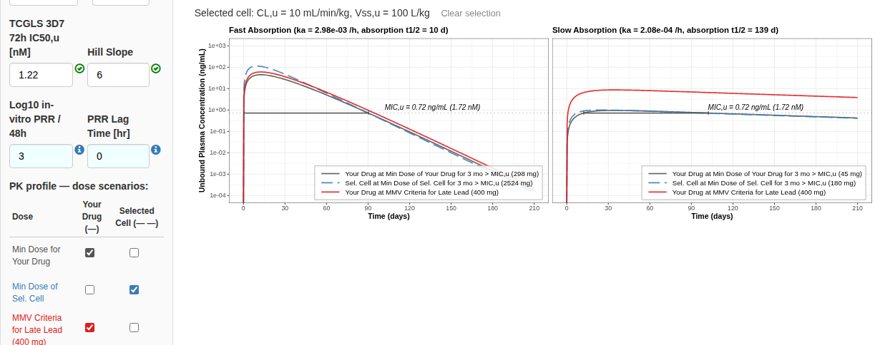
In the screenshot above, the fast-absorption panel shows that Your Drug at its own minimum dose (298 mg, dark grey) and at 400 mg (red) both maintain the concentration above the MIC,u line throughout the 3-month period, while the selected cell - which has higher CL,u and Vss,u - would require 2524 mg (blue, dashed) to achieve the same coverage.

2 Reference Guide
This chapter is a complete reference for every input, output, and interactive feature of the Prediction tab. For a guided walkthrough of a typical workflow, see Chapter 1.

Left panel inputs

Simulation parameters
Type of Main Plot: switches the main heatmap between two views:
- Max MIC,u - each cell shows the largest in-vivo MIC,u (nM) that the 400 mg MMV Critical Late-Lead dose would cover for the selected duration (answering question 1 from the Introduction).
- Min Dose - each cell shows the minimum dose (mg) needed to maintain unbound plasma concentration above the in-vivo MIC,u for the selected duration (answering question 2).
Cover Duration: the target coverage period in months (3, 6, or a custom value). All dose and MIC,u calculations are performed for this duration.
LAI Bioavailability: the fraction of the injected dose that reaches systemic circulation (0-1). For an LAI formulation without first-pass metabolism the bioavailability equals the fraction absorbed. Default: 0.8.
Molecular Weight [Da]: used to convert IC50 between nM and ng/mL for display. Default: 420 Da.

PK parameters
ka fast / ka slow (1/hour): the two absorption rate constants that define the fast and slow LAI absorption scenarios. The main heatmap and PK profile panel display both scenarios side by side. Reference values (defaults) are based on known human absorption rates: medroxyprogesterone acetate (fast, ka ≈ 2.98 × 10⁻³ /h, absorption t½ ≈ 10 days) and levonorgestrel butanoate (slow, ka ≈ 2.08 × 10⁻⁴ /h, absorption t½ ≈ 139 days).
CL,u (mL/min/kg): unbound systemic clearance. Together with Vss,u it determines the elimination half-life and the shape of the concentration-time curve.
Vss,u (L/kg): unbound steady-state volume of distribution. Together with CL,u it determines the elimination half-life: t½ = ln(2) × Vss,u / CL,u.

PD parameters
TCGLS 3D7 72h IC50,u (nM): in-vitro unbound IC50 from the TCGLS 3D7 72-hour growth-inhibition assay, corrected for assay protein binding.
Hill Slope: the steepness of the concentration-effect (sigmoidal E_{max}) relationship.
Log10 in vitro PRR / 48h: base-10 logarithm of the in-vitro parasite reduction ratio per 48-hour cycle. Together with IC50,u and Hill Slope, it is used to derive the in-vivo MIC,u.
PRR Lag Time (hr): the delay (in hours) before the antiparasitic effect begins. Default: 0.

PK profile: dose scenarios
The tickbox table in the lower left panel is a 3 x 2 grid. Each row selects a dose to simulate; each column selects whose PK (CL,u / Vss,u) to use. Ticking a cell adds the corresponding curve to the PK profile panel.
The column determines the line type:
- Your Drug - solid line, using your entered CL,u and Vss,u.
- Selected Cell - long-dashed line, using the CL,u and Vss,u of the grid cell most recently clicked in the main heatmap.
The row determines the dose and the curve colour:
Dose (row) | Your Drug column (solid) | Selected Cell column (long-dashed)
Min Dose for Your Drug (dark grey) | Your Drug’s PK at its own min dose | Selected Cell’s PK at Your Drug’s min dose
Min Dose of Selected Cell (blue) | Your Drug’s PK at the Selected Cell’s min dose | Selected Cell’s PK at its own min dose
MMV Criteria for Late Lead, 400 mg (red) | Your Drug’s PK at 400 mg | Selected Cell’s PK at 400 mg
By default two cells are ticked: Min Dose for Your Drug / Your Drug and Min Dose of Selected Cell / Selected Cell. This shows Your Drug’s curve at its own minimum dose alongside the Selected Cell’s curve at its own minimum dose - a direct comparison of how the two PK combinations perform at their respective optimal doses.

Loading parameters from a URL
Instead of entering values by hand, most of the parameters above can be pre-filled by appending a query string to the app’s URL, e.g. <app URL>/?LAI_Bioavailability=1&Clu_mLminkg=2.445&Vssu_Lkg=40&IC50=1.217&HillIN=6&invitroPRR=3 (the same example used in Section 1). This is intended primarily as the landing point for a link from another MMV tool such as MMVFree, but you can also construct one by hand or bookmark one for a compound you return to often.
URL parameter | Left panel input | Unit
Mwt | Molecular Weight [Da] | Da
kaMax | ka fast (1/hour) | 1/hour
Clu_mLminkg | CL,u [mL/min/kg] | mL/min/kg
Vssu_Lkg | Vss,u [L/kg] | L/kg
IC50 | TCGLS 3D7 72h IC50,u [nM] | nM
HillIN | Hill Slope | Slope Exponent
invitroPRR | Log10 in vitro PRR / 48h | Log10 Ratio
LagTime | PRR Lag Time [hr] | hours
LAI_Bioavailability | LAI Bioavailability | fraction, 0-1
Cover_months | Cover Duration | one of "1 Month" … "6 Months"
ka slow and Type of Main Plot cannot be set via the URL and always start at their default.
A value that is missing, cannot be parsed, or (for Cover_months) is not one of the listed choices is left at its default rather than causing an error. A numeric value outside an input’s valid range is kept but flagged with the same red status icon used for an out-of-range manually-entered value - it is not silently clamped.

Main plot
The main plot shows a grid of CL,u (y-axis, linear scale) versus Vss,u (x-axis, log scale), split into two facets - Fast Absorption (left) and Slow Absorption (right): corresponding to the two ka values.
Each cell displays:
- The primary output value (Max MIC,u in nM, or Min Dose in mg).
- Elim. t½ - the elimination half-life in days for that cell’s CL,u / Vss,u combination.
- VLE (Volume Ligand Efficiency) - a dimensionless index combining potency and distribution: VLE = -log10(MIC,u [M]) - log10(Vss,u [L/kg]). Higher values indicate a more favourable combination of low MIC,u and small volume of distribution.
In the Min Dose view, cells are colour-coded:
- Green - Min Dose ≤ 400 mg (meets the MMV criteria for late lead).
- Orange - Min Dose 401-999 mg.
- Red - Min Dose ≥ 1000 mg.
The Your Drug dot marks the position of your entered CL,u and Vss,u values on the grid. It appears in both facets and may fall between grid lines if your values lie between the discrete grid levels.
Click any cell to select it. The selection is shown by a highlighted border, the cell coordinates appear below the plot, and the PK profile panel updates immediately. Click Clear selection to deselect.

PK profile panel
The PK profile panel below the main heatmap shows simulated unbound plasma concentration-time curves on a log₁₀ scale (y-axis, ng/mL) over the coverage duration (x-axis, days). A horizontal dashed line marks the predicted in-vivo MIC,u for Your Drug.
Two sub-panels are shown side by side: Fast Absorption (left) and Slow Absorption (right). Each sub-panel overlays the dose scenarios selected in the PK profile tickbox table.
The legend labels each line with the dose scenario name and dose (mg), for example “Your Drug at Min Dose of Your Drug for 3 mo > MIC,u (298 mg)”.

Your Drug panel
The Your Drug panel on the right-hand side of the screen contains two tables:
Human PK/PD Parameters: lists all input parameters and derived quantities for your drug: clearance, volume, absorption half-lives (fast and slow), IC50,u, PRR, Hill slope, EC50,u, E_{max}, and in-vivo MIC,u. The Source column indicates whether each value was entered by the user (User input), is a formula-derived quantity (formula), or is a default (Default value).
Simulation Results: shows the minimum dose and the time to reach MIC,u for both fast and slow absorption scenarios, for 3-month and 6-month coverage durations. If a custom coverage duration other than 3 or 6 months is selected, an additional row is shown. Values marked > 9999 indicate that no feasible dose was found within the 9999 mg search limit.

